Nominate for
National Policy Forum 2012
The following candidates are supported by the Centre Left Grassroots Alliance and the Labour Representation Committee for the East Midlands places on the National Policy Forum. Nominations must be in by March 30th.
Julie Lowe, Chesterfield CLP.
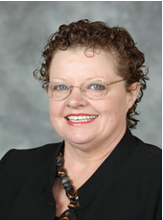
I am CLP secretary and a Brimington South ward councillor on the District Council. I am a member of UNISON, the Co-op Party and Republic. I am a keen supporter of the Labour Land Campaign. I strongly believe in an active role for members in policy formation and I want to ensure full democratic accountability in the policy making process. I would like to see more use of new technology, whilst using face to face contact with members with specific needs, such as the elderly, the infirm and homeworker parents. I am keen to see secretaries in our region working closer together on campaigns.
Charmaine Morgan, Grantham and Stamford CLP.
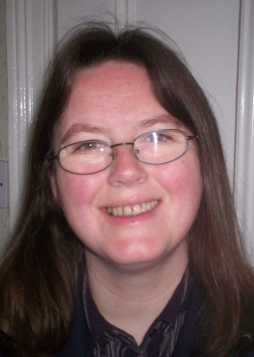
I was elected as a District Councillor in South Kesteven and have been actively campaigning for my community and working in the Labour Party to formulate strategy. A former Project Manager and former Parliamentary Candidate, I work at a local school and study with the OU. A member of GMB, Co-Op Party, SERA & LAWS, I have held CLP & Branch - Chair and Secretary positions. We successfully campaigned to save local A&E and Maternity services with 20,000 local residents. Our policies should be formed through an inclusive, transparent and democratic process. Our voices should be heard.

Marion Smith, Loughborough CLP.
I was elected in 2011 for Loughborough Southfields ward of Charnwood District Council. I am a hard working and conscientious local councillor, as well as being branch and Women’s Forum secretary, and CLP membership secretary. I was a successful runner in my younger days, and am still keenly interested in athletics. I believe in a democratic, accountable, policy making process in the Party.


